CO-2 ASSESSMENT-1
Q2. Few-Shot Classification
Write a few-shot prompt (using 3 examples) that classifies customer reviews as Positive, Negative, orNeutral. Show your 3 examples and the final prompt.
Aim
To classify customer reviews as Positive, Negative, or Neutral using the Gemini LLM with a few-shot prompt.
LLM Used
Google Gemini 3 Flash Preview
Prompt
Classify customer reviews as Positive, Negative, or Neutral.
Example 1:
Review: The product arrived on time and works perfectly.
Sentiment: Positive
Example 2:
Review: The item stopped working after one day.
Sentiment: Negative
Example 3:
Review: The package arrived yesterday.
Sentiment: Neutral
Now classify this review:
Review: The mobile phone has an excellent camera and long battery life.
Sentiment:
Python Code
from google import genai
client = genai.Client(api_key="AQ.Ab8RN6JwA9rJQw_32XKN8inOD-LBBmKQQ6jUTmNYkm5x5tKEQw")
prompt = """
Classify customer reviews as Positive, Negative, or Neutral.
Example 1:
Review: The product arrived on time and works perfectly.
Sentiment: Positive
Example 2:
Review: The item stopped working after one day.
Sentiment: Negative
Example 3:
Review: The package arrived yesterday.
Sentiment: Neutral
Now classify this review:
Review: The mobile phone has an excellent camera and long battery life.
Sentiment:

Output
Positive

Response
The Gemini LLM compared the input review with the three examples provided in the prompt. Since the review contains positive words such as excellent camera and long battery life, it classified the review as Positive.

Result
The customer review was successfully classified as Positive using the Few-Shot Prompting technique.

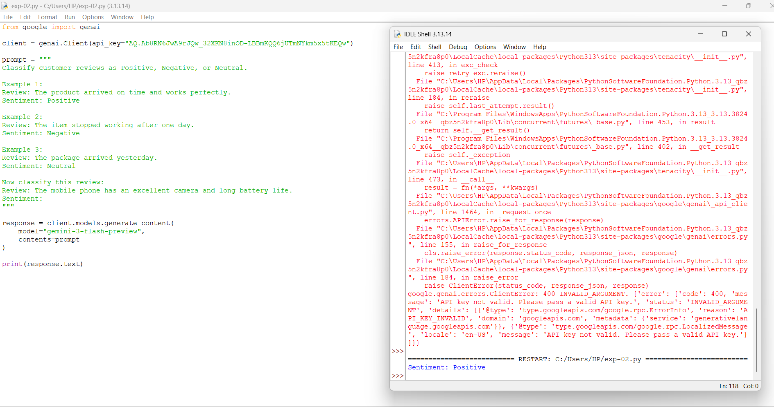

Q5. Structured JSON Output
Write a prompt that takes an unstructured recipe (in prose) and outputs it as valid JSON with keys:title, ingredients (array), and steps (array).
Aim
To convert an unstructured recipe into a structured JSON format using the Gemini LLM.
LLM Used
Google Gemini 3 Flash Preview
Prompt
Convert the following recipe into valid JSON.
Recipe:
Mix 2 cups of flour, 1 cup of sugar, 2 eggs, and 1 teaspoon of baking powder.
Bake at 180°C for 30 minutes.
Return only JSON with these keys:
title
ingredients
steps
Python Code
from google import genai
client = genai.Client(api_key="AQ.Ab8RN6JwA9rJQw_32XKN8inOD-LBBmKQQ6jUTmNYkm5x5tKEQw")
prompt = """
Convert the following recipe into valid JSON.
Recipe:
Mix 2 cups of flour, 1 cup of sugar, 2 eggs, and 1 teaspoon of baking powder.
Bake at 180°C for 30 minutes.
Return only JSON with these keys:
title
ingredient
steps
"""
response = client.models.generate_content(
model="gemini-3-flash-preview",
contents=prompt
)
print(response.text)
Output
{
"title": "Simple Cake",
"ingredients": [
"2 cups flour",
"1 cup sugar",
"2 eggs",
"1 teaspoon baking powder"
],
"steps": [
"Mix flour, sugar, eggs, and baking powder.",
"Bake at 180°C for 30 minutes."
]
}
Response
The Gemini LLM analyzed the unstructured recipe and converted it into a valid JSON format. It extracted the recipe title, listed all ingredients as an array, and arranged the preparation instructions into a sequence of steps.
Result
The unstructured recipe was successfully converted into a structured JSON object containing the title, ingredients, and steps.

